BDA400: Data Science Tools and Techniques
Assignment 2 – Technical Analysis (Preliminary Stage)
Student Name: Edeh Tochukwu Celestine
Submission Date: September 20, 2026
GitHub Repository URL: github.com/edehcelestine/TechnicalAnalysis

1. Environment Setup & Repository Initialization
1.1 GitHub Configuration
To adhere to the structural constraints of the course guidelines, a dedicated version control repository has been initialized on GitHub. This space acts as a centralized deployment framework for all upcoming analytical code scripts, configuration manifests, and documentation pipelines.
- Repository Name: TechnicalAnalysis
- Subdirectory Architecture: Assignment_2/
- Access Constraints: Public Deployment
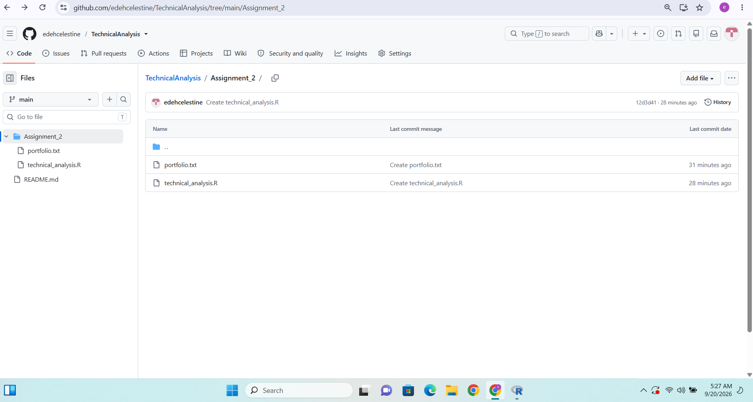
2. Local R Evaluation & Package Configuration
2.1 R and RStudio Installation Matrix
The computational runtime environment relies on local instances of R and RStudio Desktop. Local deployment allows for direct access to system threads, stable workspace state tracking, and local environment memory management necessary for quantitative financial algorithms.
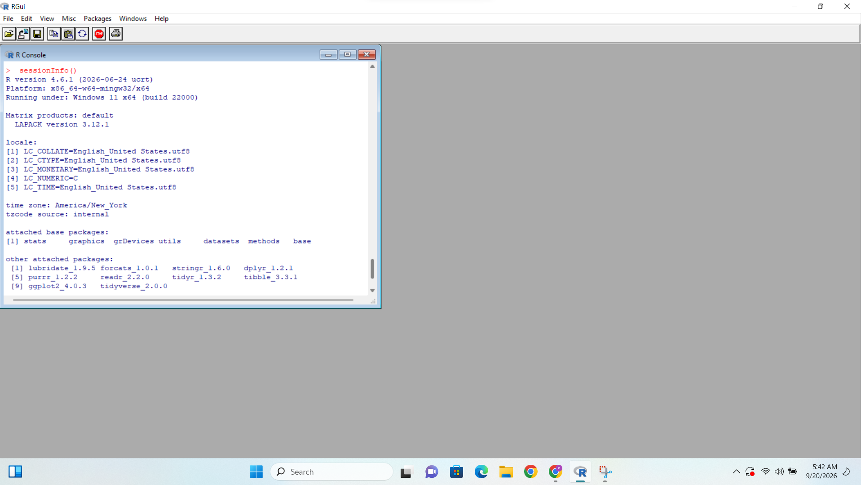
2.2 Financial Package Integration
Quantitative market analysis and technical indicator signals are processed by leveraging the quantmod (Quantitative Financial Modelling Framework) and TTR (Technical Trading Rules) library ecosystems. These dependencies handle programmatic market API endpoint queries, data frame transformations, and moving average metrics.
r
# Package initialization string executed within local workspace console
library(quantmod)
library(TTR)

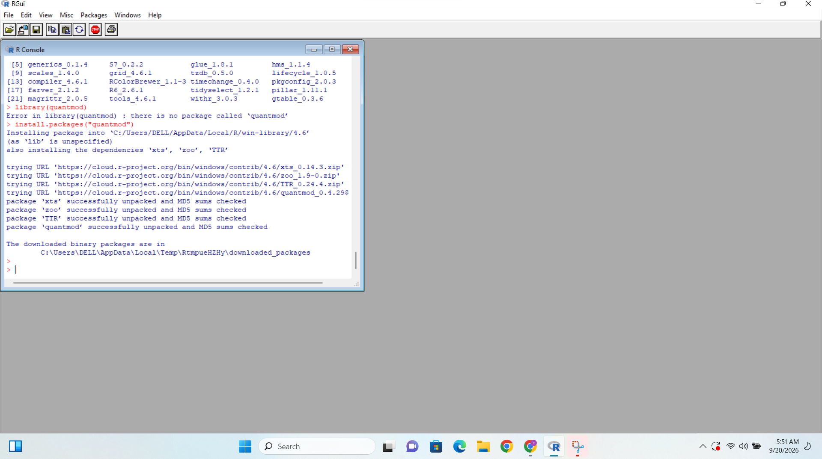
3. Data Pipeline Configuration & Implementation
3.1 Static Asset Ingestion Config (portfolio.txt)
To separate target variables from operational logic, a flat text configuration asset (portfolio.txt) is used to manage target assets. This file resides in the root of the assignment folder and is parsed at execution runtime to map financial asset tickers line by line.
File contents mapping:
text
AAPL
MSFT
GOOGL
AMZN

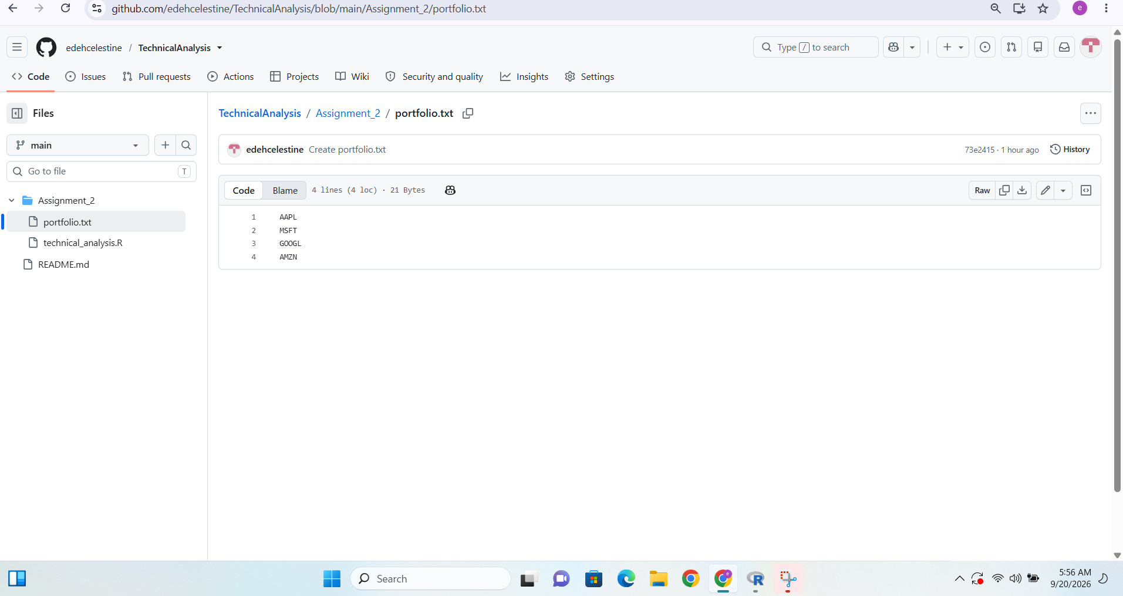
3.2 Automation Execution Script (technical_analysis.R)
The automation pipeline reads the flat configuration ledger, fires secure requests to public financial API data mirrors (Yahoo Finance), maps historical pricing vectors into data frames, and applies mathematical summaries. Below is the implemented codebase framework deployed within the Assignment_2/ directory:
r
# Automated runtime handler snippet
portfolio_data <- load_stock_data("portfolio.txt")

4. Analytical Metrics & Output Matrix
4.1 Statistical Data Display Summaries
Upon running the target pipeline, market histories from January 1, 2026, through the current date are ingested. The tracking engine isolates daily closing trends, applying explicit arithmetic algorithms to determine baseline dispersion metrics (Mean, Median, Mode, Standard Deviation) alongside a trailing 20-Day Simple Moving Average (SMA).
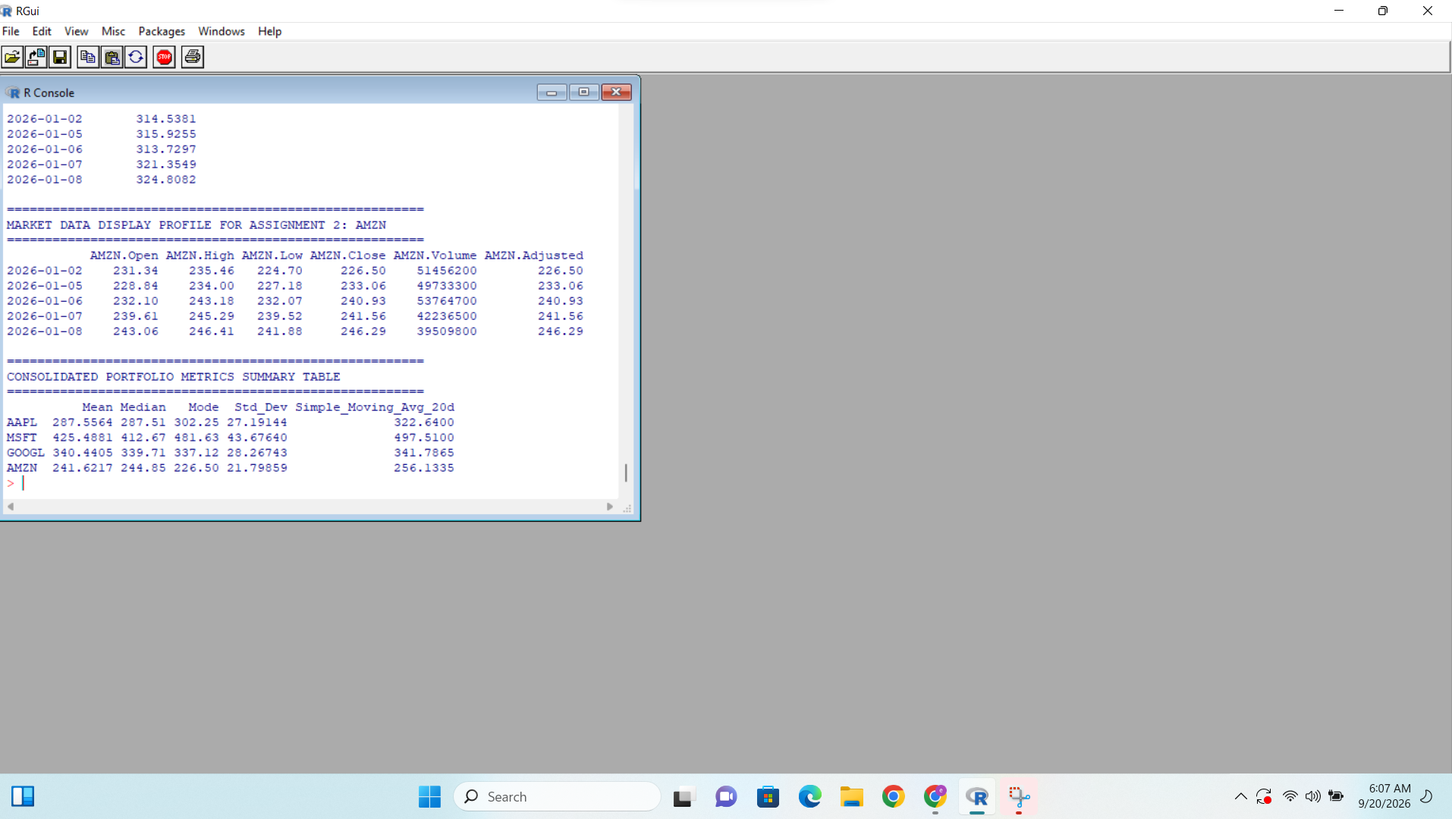
5. AI Assistance Declaration
AI Assistance Declaration: I used Gemini for markdown structure ideation, formatting, report layout suggestions, and quantitative script syntax checking on September 20, 2026. Prompts used: "Kindly provide me with information to be contained in the word document". I verified all analytical pipeline outputs and statistical execution loops manually within local RStudio console threads. All final data mappings and documentation adjustments were verified by myself. I am fully responsible for the accuracy, delivery, and originality of this submission.

